Sibford Gower Primary School steps in to fill gap left by nursey closure
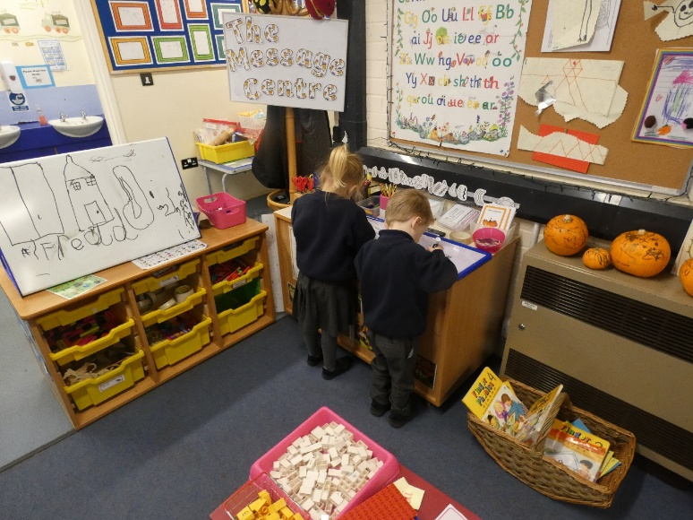
After many years of highly valued service, the owner the Ark private nursery in Epwell made the difficult decision to close the provision in July 2021. This gave parents just 3 months to find alternative childcare. As soon as she was made aware of this, the headteacher of Sibford Gower Primary School, with the full support of colleagues within the Warriner Multi Academy Trust, mobilised to make a fast-track application to the department for Education in order to open a nursery on the school site.

This application was granted, and the school opened its doors to its first group of 3–4-year-olds in September 2021. The Warriner MAT has a mix of primary and secondary schools located in Oxfordshire and Northamptonshire and has an ethos of collaboration and sharing of best practice. This sharing of expertise and experience supported the school in ensuring that all the necessary systems were in place to enable the smooth running of the provision from day one.

The headteacher, Mrs Jane O’Sullivan said, “We have always had very strong transition arrangements with The Ark nursery and were delighted to be able to step in and make sure there was no lapse in nursery education provision for the local community. The Early Years staff are doing a brilliant job and the current nursery children have settled quickly. They are thriving within a safe, creative, thoughtful and nurturing environment which meets their learning and social needs well.”

Some of the really positive feedback from parents includes:
“I love the fact that it is so play-based. My child’s play has developed so well since starting here”
“My child is really enjoying being in nursery here. He loves his teachers.”
“My child loves being able to play with the Reception children too. He is learning well from being with older children and is getting opportunities to do all sorts of things he might not be able to do if it were a ‘stand-alone’ nursery”.
“Even though the provision is new, it feels like the nursery has always been here.”

Dr Annabel Kay (CEO of The Warriner MAT) said “Villages depend upon children and young families to survive. Child care is a lifeline for these families. I am delighted that we have been able to respond so quickly to replace this provision and am so proud of my staff for the amazing experiences that they are providing for the children in their care.”

The Early Years provision caters for children from the beginning of the term after their third birthday until they are five. Although take up is strong and places are filling up fast, there are places available. If you would like to find out more, please call the school on 01295 780270.

