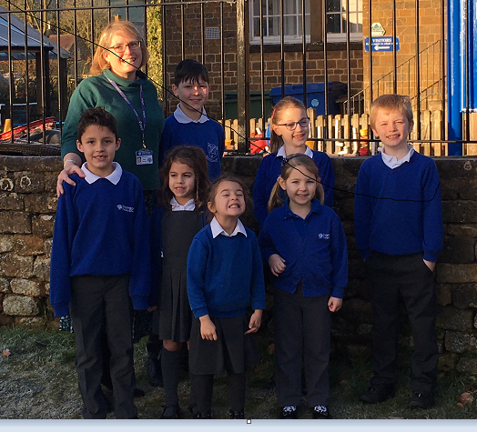
A new year, a new term and a new headteacher for Hornton Primary school.
Children, staff and parents welcomed their new Headteacher on their return from the Christmas holidays. Mrs Wendy Whitehouse joined the team at Hornton Primary School after having successfully led Farthinghoe Primary School, just over the border in Northamptonshire, for 8 years. At Farthinghoe, Mrs Whitehouse developed an ethos where all her children are nurtured and supported to fly. Children love their school, are proud of their learning and thrive. It is for all these reasons that Farthinghoe has been significantly over subscribed for several years.

Mrs Whitehouse brings this wealth of experience to Hornton. Both Hornton and Farthinghoe are members of the Warriner Multi Academy Trust so she already knows the school extremely well. She also lives within the local community and as such is a familiar face to many of the parents.

Mrs Whitehouse said,” I am delighted to have been appointed Headteacher of Hornton School. After my very first visit, I realised why parents choose our small village school, which truly values the individual child. My aim, as Headteacher, is to give the children a breadth of opportunity where each individual’s ‘best’ is recognised and celebrated. I love to challenge children so they learn, grow and achieve both academically and personally. After working with the staff and children during the first two weeks of school, I am already valuing the warm and vibrant atmosphere, which is enhanced by the strength of the relationships between the staff, parents and pupils. I feel honoured and privileged to have been given the opportunity to lead this wonderful school.”

Dr Annabel Kay (CEO of the Warriner Multi Academy Trust) said “The trust has always been committed to developing and retaining our very best colleagues. The Headteacher vacancy at Hornton gave us the chance to offer the opportunity for one of our most experienced leaders to lead a larger school. We have also been able to promote another talented colleague into the leadership role at Farthinghoe. I am proud that we have been able to develop such talented staff and give them opportunities to grow.”
Hornton has always been a very special part of the Warriner Multi Academy Trust family of schools and Mrs Whitehouse, along with the trust team will expertly lead it through the next phase of its journey. If you would like to find out more, please contact the school on 01295 670335.

Hornton has always been a very special part of the Warriner Multi Academy Trust family of schools and Mrs Whitehouse, along with the trust team will expertly lead it through the next phase of its journey. If you would like to find out more, please contact the school on 01295 670335.

